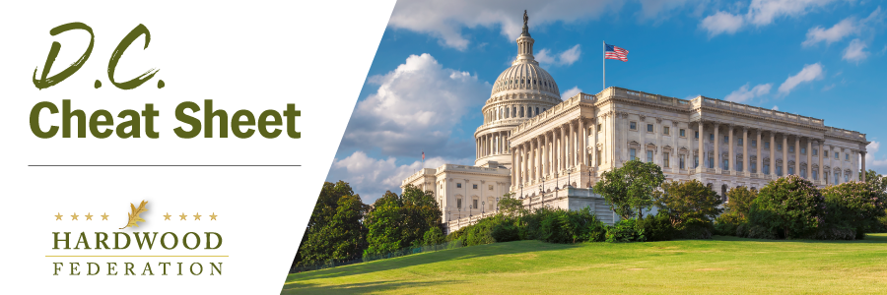

Quick Updates from Your HF Team

House Lawmakers Push “Resolution of Disapproval” to Revoke New NLEB Rule

On March 30, Rep. Pete Stauber (R-MN) introduced a “Resolution of Disapproval” under the Congressional Review Act (CRA) to rescind the U.S. Fish and Wildlife Service’s “endangered” listing of the Northern Long Eared Bat (NLEB) under the Endangered Species Act. In late November 2022, the USFWS finalized a rule reclassifying the NLEB from “threatened,” to “endangered,” thereby triggering more red tape for harvesting permits. Although the measure is likely to pass the House and may fare well in the Senate, it would require President Biden’s unlikely signature to cross the finish line. Meanwhile, the USFWS is offering an Interim Consultation Framework, that will provide guidance through March 31, 2024, for projects taking place within the northern long-eared bat’s 37-state range.

Administration Allocates $34M to Support Forest Management, Reduce Wildfires

On April 6, USDA announced it will fund projects, primarily in the western states, to promote sustainable forests and support the “wood products economy” to mitigate wildfire risk. According to USDA Secretary Tom Vilsack, by promoting the manufacture of wood products using small diameter wood and biomass, USDA can “reduce the risk of catastrophic wildfires [and] support existing jobs” in rural and underserved communities. USDA states that it will allocate the majority of these resources on “landscapes identified by the Forest Service’s Wildfire Crisis Strategy,” which focuses on 10 landscapes in the western states.

New WOTUS Rule Remains in Murky Waters

On Thursday, April 6, President Biden vetoed Congress’s “Resolution of Disapproval” that would rescind the Administration’s stringent Waters of the United States (WOTUS) Rule to expand permitting over wetlands and other bodies deemed to be subject to federal jurisdiction. As the Senate contemplates a possible but unlikely veto override, all eyes now turn to the Supreme Court, which is expected to rule this year in the case of Sackett v. EPA. This case involves landowners suing federal regulators for tying up their property over a wetlands designation and may result in a decision which in turn invalidates elements of the new clean water rule. If that occurs, EPA will have to go back to the drawing board and draft yet another rule, this time in compliance with whatever the Supreme Court may require.

