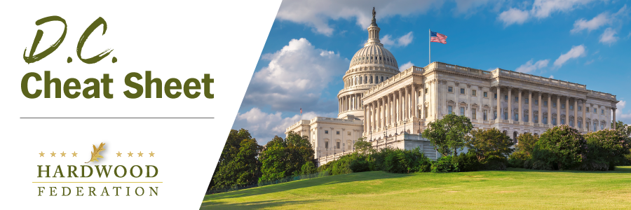

Quick Updates from Your HF Team
Industry Advocates Use of Hardwood Sustainability Data in Federal GHG Accounting
On August 10, the Hardwood Federation submitted comments to USDA responding to its Request for Information related to a federal strategy that will more accurately measure and monitor greenhouse gas (GHG) emissions and capture for the agriculture and forest sectors. The Federation used the opportunity to showcase the sustainability benefits of hardwood products, citing recent Environmental Product Declarations for hardwood flooring as examples, and to continue advocacy for authorization of a Forest Products Laboratory (FPL) study that will quantify the amount of carbon stored in wood products. Although USDA stated that the current RFI will not necessarily result in a formal rulemaking as a next step, it will inform efforts across the federal government to gather data related to carbon accounting programs.
Hardwoods, Business Community Oppose More Stringent Air Emissions Standard
In response to a study from the National Association of Manufacturers showing that stricter EPA standards for particulate matter (PM) could place more than 800,000 manufacturing jobs at risk nationwide, the Hardwood Federation is signing a letter led by the U.S. Chamber of Commerce urging EPA to keep the current PM standards in place. In March, the Hardwood Federation submitted comments to EPA outlining arguments that the standard currently in place continues to improve air quality while tightening the standard would require up to 217 U.S. sawmills to conduct expensive testing to assure compliance with a new standard. The current rulemaking is discretionary on the part of EPA, not being driven by statutory mandates or court orders. EPA is expected to make a decision about whether to tighten or keep the current EPA standard by the end of the year.
USDA Warns Forests Could Become Net Carbon Emitters
Consistent with industry advocacy on forest management and old-growth issues, USDA has issued a report showing that forests could be classified as net emitters of carbon rather than absorbers, based largely on the aging and decay of forestland managed by federal agencies. According to USDA, beginning in two years, the ability of the forests to store carbon could see a steep decline, resulting in emissions of “100 million metric tons of carbon a year as their emissions from decaying trees exceed their carbon absorption.” Unless policymakers intervene, U.S. forestland could rank as a “substantial carbon source by 2070,” USDA says.

