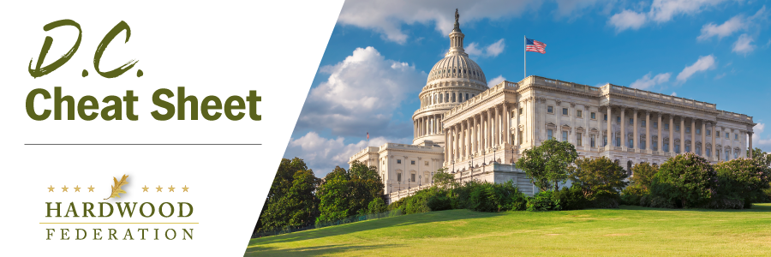
Quick Updates from Your HF Team
House Lawmakers Urge End-of-Year Tax Fix
On November 29, a letter led by Rep. Rudy Yakym (R-IN) and signed by almost 150 House Republicans was sent to House Speaker Mike Johnson (R-LA) to urge action by the end of this year on the expired and expiring business tax benefits that were authorized by the Tax Cuts and Jobs Act of 2017. None of the signatories sits on the House Ways & Means Committee and that was by design. Rep. Yakym wants to show leadership that there is strong support across the Republican Caucus for action by year’s end on these key tax benefits. These benefits include restoration of 100 percent depreciation equipment, the R&D Tax Credit which lapsed in 2022, and restoring full business interest deductions, known in tax world as EBITDA.
Manufacturers Oppose EPA’s Proposed Power Plant Rule
In August, the National Association of Manufacturers (NAM) filed comments with EPA advocating against a proposal that would effectively force existing power plants to adopt carbon capture technology not yet scaled for deployment onto the grid. Characterizing the proposal as “aspirational rather than pragmatic,” NAM estimates the compliance cost over a ten-year period to be $14 billion. Manufacturers also point out that the 10-year transition to carbon technology is unrealistic based on the multi-year permitting process that power plants would face to fulfill National Environmental Policy Act (NEPA) requirements.
National Defense Authorization Act on Deck
Although final passage of the National Defense Authorization Act stalled earlier this fall, federal lawmakers appear poised to pass a final package during the run-up to the Christmas break, which officially kicks off on December 15. Last night, House and Senate negotiators on a compromise NDAA bill released text, which includes authorization of a continuing education curriculum and pilot program for sustainable construction materials, including mass timber. The Federation will keep you posted on final passage as the compromise bill moves forward.

