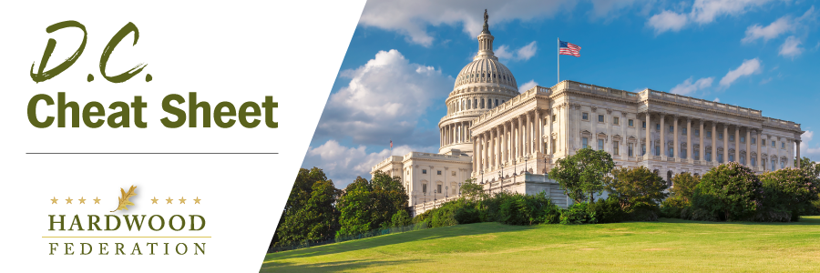
Quick Updates from Your HF Team

EPA Poised to Release Stringent Air Quality Standard, Industry Prepares Remedies
Anticipating the release of a stringent air quality standard for PM 2.5, aka “fine particulate matter” from EPA, industry is bracing itself for a significant increase in the number of “non-attainment” counties nationwide that will have to look at costly pollution abatement measures to achieve compliance. In addition to planning litigation that could delay implementation of the new standard, industry groups will also examine legislative remedies, likely to include appropriations “riders” that would hamstring EPA’s ability to implement a new rule during the next fiscal year. As reported earlier, although a new rule would primarily impact large facilities in the wood products sector, there could be downstream impacts, up to $900 million in compliance costs, for smaller operations and manufacturers. The Federation will keep you posted on EPA’s final decision.
House Passes Tax Package, Sends to Senate
After much negotiation with members of his own GOP Caucus, House Speaker Johnson (R-LA) moved forward on Wednesday with a vote on the House tax package, which passed under expedited procedures to bypass the amendment process. The bill includes restoration of business interest deductions, the R&D tax credit and full expensing of equipment. Timing in the Senate remains uncertain at this time. The Federation will keep you posted on developments as they unfold.
Tell House Lawmakers to Co-Sponsor Hardwood Access Development Program Act! Join more than 130 of your industry colleagues who have already sent letters to their House lawmakers urging them to sign onto the hardwood access bill. You can support the industry by contacting your U.S. representative today and sending a letter urging more co-sponsors for H.R. 6880.
Mark Your Calendar Today! The Hardwood Federation has scheduled Fly-In 2024 for Tuesday, May 21 to Thursday, May 23. Save the dates and come to Washington to make your voice heard on Capitol Hill! Stay tuned for details related to registration information and Fly-In agenda.

