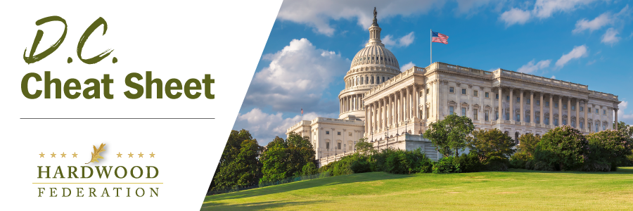

Quick Updates from Your HF Team
Sens. Feinstein, Collins to Roll Out Bipartisan Community Wood Bill
Joining forces across party lines, Sens. Dianne Feinstein (D-CA) and Susan Collins (R-ME) are gearing up to re-introduce the Community Wood Facilities Assistance Act, a bill that would funnel resources from the Community Energy and Wood Innovations Program toward small wood products facilities. The bill would increase the maximum grant per facility from $1 million to $5 million and double the budget for the program from $25 million to $50 million. The bill will also rebrand the program as the “Community Wood Facilities Grant Program” to avoid confusion with the similarly named “Wood Innovations Grant Program.” The Federation will keep you posted on developments related to this important bill.
USFWS Finalizes Bat Habitat Plan for Lake States Region
The USFWS has recently finalized a Bat Habitat Conservation Plan (HCP) for the Lake States Region (LSR), including Michigan, Minnesota and Wisconsin. Fortunately for industry, the HCPs conservation strategies are similar to the current 4(d) Rule for “threatened” bat populations under the Endangered Species Act that land managers have been implementing since 2015. The LSR bat plan may also serve as a model for other states wanting to develop an HCP, delivering flexibility to a broader swath of landowners and sawmills.
Demand for Wood Banks Rises as Energy Prices Climb
As fuel prices continue to climb during the winter months, wood banks in Maine are increasing their supplies to meet rising demand from those priced out of home heating oil and natural gas. In October, the University of Maine (UMaine) received a $62,500 grant from USDA for the National Wood Bank Project, a program that will help create more wood banks and exchanges among similar programs throughout the country. “Ultimately, we will create a peer network of wood banks to support one another as they serve their communities and help those in need with heat through the winters,” states a UMaine spokesperson.
Mark Your Calendar! The Federation Fly-In is Back, June 13 – 15, 2023

