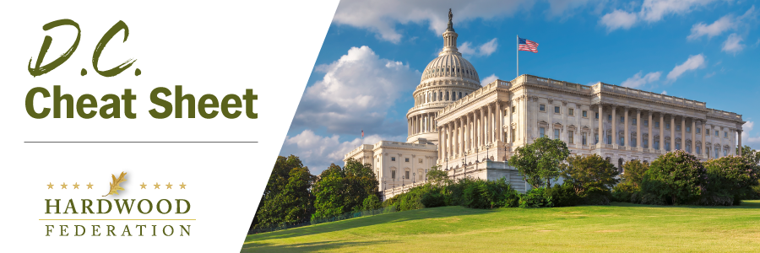
Quick Updates from Your HF Team

Farm Bill Roadblocks Increase by the Day
Progress on a new farm bill is turning into the latest casualty in the ongoing congressional battle over the budget, as lawmakers struggle to reach consensus on a price tag for big ticket items, including nutrition assistance. This became clear on Tuesday when Sen Ag Committee Chair Debbie Stabenow (D-MI) stated publicly that she’d rather drop the farm bill altogether, and keep the current 2018 law in place, than agree to cuts in nutrition programs while reallocating climate funds. On the House side, Ag Committee Chair GT Thompson (R-PA) has been working to maintain bipartisanship, focusing on centrist Democrats to support his budget solutions, which include repurposing left-over funds from the Inflation Reduction Act, the Biden Administration’s key climate initiative, toward conservation and other programs, a move now publicly opposed by his senate counterpart. Although industry had hoped to be able to review farm bill text in February, release of a draft bill remains a moving target.
Industry Opposes Import Bill
On February 23, the Federation team spoke to staff with the House Natural Resources Committee, advocating against H.R. 7157, a bill that would significantly compress the timelines necessary to screen wood product imports for violations of the Lacey Act, a statute that the industry supports in order to promote a level playing field in the domestic hardwood market. On February 14, the House Natural Resources Subcommittee conducted a hearing to receive perspectives on the bill, at which time the Federation submitted a letter for the record arguing against counter-productive changes to the Lacey Act. According to staff with the House Natural Resources Committee, lawmakers have no plans to advance the bill at this time and are committed to working with interested parties, including the Hardwood Federation. We will be keeping a close eye on this bill.
EPA Outlines Draft Labelling Program for Low Carbon Construction Materials
On February 27, the Federation participated in a webinar with EPA, which has rolled out a draft labelling program for low carbon construction materials. Unfortunately, the proposal, as currently written, adopts “an initial focus” on steel, asphalt and concrete, leaving the door open for similar labels for other materials using “a phased approach.” Prior to the current rulemaking, the Federation and its wood products allies submitted comments to EPA on a “Request for Information” related to low carbon construction materials, underscoring the fact that wood products are the quintessential low-carbon material.
Make Your Reservation Today! The Hardwood Federation has scheduled Fly-In 2024 for Tuesday, May 21 to Thursday, May 23. Save the dates and come to Washington to make your voice heard on Capitol Hill! To register for Fly-In 2024, please click here.

