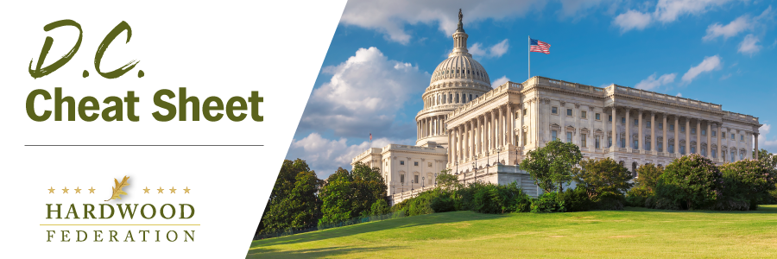

Quick Updates from Your HF Team

Allegheny Wood Products Hosts House Hearing on “State of the American Economy”
On Monday, February 6, the House Ways & Means Committee kicked off its agenda for the 118th Congress by taking a road trip to the Federation’s Alleghany Wood Products (AWP) in Petersburg, WV, and reviewing the “State of the American Economy.” AWP’s VP for Operations, Tom Plaugher, testified before lawmakers and highlighted challenges posed by the entire hardwood sector, including rising fuel costs, supply chain disruptions, a lack of qualified workers and increasing amounts of red tape from government agencies. Plaugher also used the platform to amplify an important industry message, reminding lawmakers that well-managed forests can provide “forest products, opportunities for recreation, and a long-term tool for carbon capture for generations to come. That is all in addition to the jobs and economic impact these forests provide.” Although the hearing was broadcast live, you can view a recording by clicking here.

Bipartisan “Supply Chain Package” Planned in the House
In a narrowly divided House, many bills that aim to untangle supply chains are gaining rare, bipartisan support and may come together in a package this spring, increasing the chances of a floor vote, according to Congressional Supply Chain Caucus Chair Dusty Johnson (R-SD). On January 24, U.S. Reps. Johnson (R-S.D.) and Jim Costa (D-CA) introduced the “Safer Highways and Increased Performance for Interstate Trucking (SHIP IT) Act” (H.R. 471), which aims to increase safety and shipping capacity for truckers and create recruitment incentives for drivers. Not to be outdone, Reps. Abigail Spanberger (D-VA) and Mike Gallagher (R-WI) plan to reintroduce the “Strengthening Supply Chains Through Truck Driver Incentives Act,” which will tackle the trucker shortage by promoting apprenticeships. In addition to the bills described above, the LICENSE Act (Licensing Individual Commercial Exam Takers Now Safely and Efficiently Act) is also being readied for reintroduction. This bill would cut red tape in the rigid Commercial Drivers License (CDL) issuance process.
Reps. Thompson and Bonamici Promote Career/Technical Ed Month
In another example of bipartisanship, hardwood industry allies Reps. GT Thompson (R-PA) and Suzanne Bonamici (D-OR), co-chairs of the House Career and Technical Education Caucus, are planning to introduce a resolution promoting Career and Technical Education (CTE) month to highlight the impact of CTE programs. The goal is to alleviate worker shortages by promoting positions in high-demand, high-skill, and high-wage jobs and career fields that often go unfilled. Specifically, the resolution will encourage educators, school counselors, administrators, and parents to promote career technical education as a respected educational pathway for students. Per a request from Rep. GT Thompson’s office, the Hardwood Federation plans to sign on to support the resolution.

