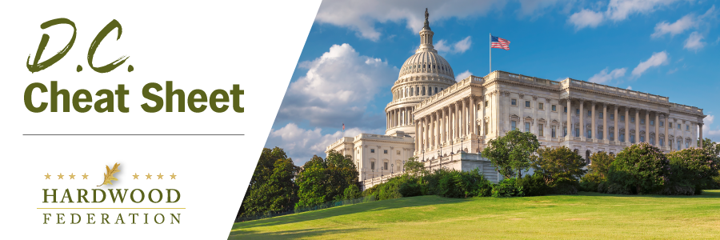
Quick Updates from Your HF Team

Congressional Tax Leaders Push Pro-Business Tax Breaks
On Tuesday, January 16, House Ways and Means Committee Chairman, Rep. Jason Smith (R-MO-08) and Senate Finance Chairman, Sen. Ron Wyden (D-OR) announced a bipartisan tax deal, the Tax Relief for American Families and Workers Act, which will be marked up in the House tax committee on Friday. Key components of the tax package include a trio of GOP priorities, restoration of business interest deductions, the R&D tax credit and full expensing of equipment, were agreed to in exchange for a more robust child tax credit backed by Democrats. As we write this, the path forward remains uncertain. Lawmakers had been looking at attaching taxes to a Continuing Resolution (CR) to fund federal operations beyond January 19 and February 2, per the two-tiered funding bill passed by Congress late last year. But late Wednesday, Republicans in the House were saying they intend to pass this in the House under expedited procedures, and that it will run independent from the government funding CR. The Federation will keep you posted on developments as they unfold.
Administration Weighs Stringent Air Quality Standard
EPA is expected to kick off the new year by unveiling a new, more stringent air quality standard for PM 2.5, aka “fine particulate matter.” Although this would primarily impact large facilities in the wood products sector, there could be downstream impacts for smaller operations and manufacturers. There is currently a debate within the Administration holding up release of the final regulations, with White House staff pressuring EPA to reduce the standard to a level of 9 micrograms per cubic meter from the current level of 12 micrograms, a move that could subject many sawmills to more red tape related to environmental permits. According to Administration sources, EPA had been considering a more flexible standard of 10 micrograms per cubic meter, an outcome that industry prefers over the more costly alternative while still preferring the current standards. The Hardwood Federation team has joined our wood products allies, including the American Wood Council and the American Forest and Paper Association to advocate against imposing unreachable standards. The Federation will keep you posted on EPA’s final decision.
Congressional Retirements to Spike in 2024
Election year 2024 portends big changes for the makeup of the new Congress when it convenes in January 2024, given the wave of incumbents who’ve announced that they will not be running for re-election in November. So far, 38 House lawmakers, or nearly 10 percent of the entire chamber, and seven senators are bowing out of the 2024 race to keep their seats. On the House side, several lawmakers are running for new offices whereas 22 members are opting for outright retirement in numbers roughly even between party lines. On the senate side, only Sen. Mike Braun (R-IN) is running for another office, running as a candidate for governor, whereas six are exiting political offices altogether.
Make your voice heard! The Hardwood Federation wants your feedback on federal policies that impact your business. To identify the industry’s top priorities for 2024, please click here.

