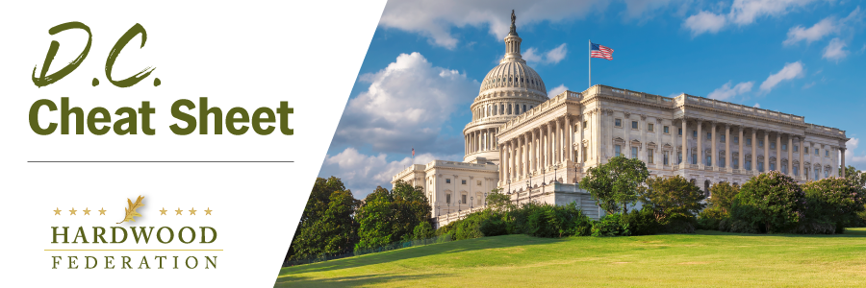

Quick Updates from Your HF Team

Feds Push Back Enforcement Date for Northern Long-Eared Bat

On January 25, the U.S. Fish and Wildlife Service (USFWS) extended the effective date of the final rule reclassifying the northern long-eared bat (NLEB) from threatened to endangered from January 30, 2023 to March 31, 2023. Giving industry an extra 60-days of breathing room, regulators state that they want to give stakeholders enough time to “preview” temporary guidance documents and management tools before the rule becomes effective. As previously reported, the feds formally up classed the NLEB to endangered in final regulations issued in November. For more information on the NLEB, please click here.

Senate Ag Panel Set to Review Farm Bill Priorities

On January 25, Senate Ag Committee Chair Debbie Stabenow (D-MI) and Ranking Member John Boozman (R-AR) announced the panel’s first hearing of the year on the 2023 Farm Bill, scheduled for Wednesday, February 1. Committee members will be focusing on trade and horticulture issues and receive testimony from USDA’s undersecretary in charge of trade and foreign agricultural affairs. The committee has set up a rigorous schedule for the first quarter, including a hearing on conservation and forestry programs scheduled for Wednesday, March 1.

Administration Fights Wildfires with More Dollars
On January 19, USDA Secretary Vilsack announced that the Administration would allocate an additional $490 million to reduce wildfire risk across the country. The new dollars will focus on 11 landscapes in high-risk areas in Arizona, California, Idaho, Nevada, Oregon, Utah and Washington. USDA cites money made available by the Inflation Reduction Act and Bipartisan Infrastructure Law as the source of the new funds. To learn more about new efforts to combat wildfires, please click here.

