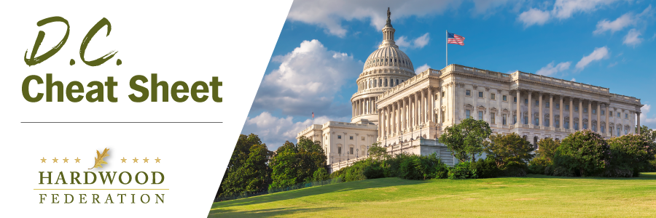

Quick Updates from Your HF Team

House Leadership Logjam Creates Instant Gridlock

Following intense negotiations and three days of voting, as of press time this afternoon, Rep. Kevin McCarthy (R-CA) has failed to win the 218 votes necessary to secure the House Speakership. As House members plot next steps to resolve the leadership issue, lawmakers have been forced to delay important housekeeping matters, including the swearing-in of members and approval of committee chairs such as GT Thompson, who is designated to lead the ag panel. The Senate, on the other hand, completed its housekeeping business on Tuesday without controversy and will be in recess until Jan. 23. Your HF team will keep you posted on key leadership developments in Congress as they unfold.

Congress Re-Opens to Pre-Covid Protocols

The Capitol Complex fully reopened to the public on Tuesday afternoon, dropping restrictions on unescorted visitors imposed by COVID and security concerns put in place since 2020. Members of the hardwood industry and other visitors will no longer need an escort to enter the office buildings. The Capitol’s Attending Physician, the U.S. Capitol Police and Visitor Services coordinated the plans to reopen in a manner consistent with a request from Rep. McCarthy (R-CA) submitted on November 10.

Administration Issues New “Waters of the United States” (WOTUS) Rule

On December 30, the Environmental Protection Agency (EPA) announced a final rule to establish a definition of “waters of the United States” (WOTUS) that will attempt to settle the regulatory back-and-forth over Clean Water Act (CWA) jurisdiction that has prevailed during the course of the past three Administrations. The final rule, which will define the scope of federal water permits, restores key requirements that were in place prior to the “navigable waters rule” issued in 2015. Ag groups, including the Farm Bureau, are criticizing the new rule, claiming it will expand regulators’ reach over private property. Congressional leaders are also weighing in, with industry ally Rep. GT Thompson (R-PA) characterizing the rule as a “land grab.” The Federation will keep you posted on legislative and legal remedies that will emerge to mitigate the impacts of the new rule.

