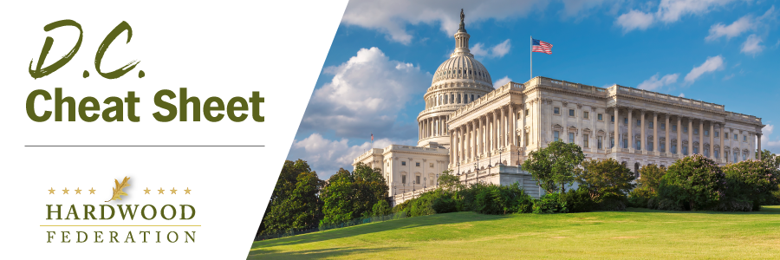

Quick Updates from Your HF Team
House Funding Bill Promotes Carbon Neutrality of Biomass
On July 13, a House Appropriations Subcommittee released a Fiscal Year (FY) spending bill requiring multiple federal agencies, including EPA, USDA and Department of Energy, to be on the same page with respect to forest bioenergy. Specifically, the bill states that the agencies will recognize “the carbon neutrality of bioenergy and recognize biomass as a renewable energy resource.” Although the spending bill has a few hurdles to jump before crossing the finish line, including floor votes on both sides of the Capitol, it will be a heavy lift moving forward to strip industry biomass from the bill as it moves through the legislative process. Stay tuned for updates on FY 2024 spending bills and how they will impact the sector.
USDA Opens Funding for “REAP” Grants
On July 14, USDA opened the Rural Energy for America Program (REAP) Technical Assistance Grant Program for applications. Eligible applicants, which include not-for-profit groups and sole proprietorships, among others, will cover activities that help “agricultural producers or rural small businesses to apply for assistance under REAP for energy efficiency Improvements, or Renewable Energy Systems.” Over the years, companies deploying biomass heat and power systems have benefited from grants authorized by REAP. USDA will accept applications for grants, which will range from $100,000 to $500,000, through August 15.
USFS Conducts Webinar on Mature, Old Growth Forest “Threat Analysis”
On July 17, USFS conducted a two-hour webinar as part of its ongoing outreach related to the April 2022 Executive Order on strengthening the nation’s forests, this time with a focus on developing a “threat analysis” for mature and old growth forests and weighing factors such as wildfire and insect and disease risk. Hardwood team members participated on the call and joined other industry representatives who expressed concerns that the exercise would result in further erosion of active forest management and argued that timber harvest and forest thinning, for example, “do not constitute threats” to federal lands. USFS officials responded that the agency is charged with forest management as part of its core mission and is therefore not likely to cut back on forest management unless Congress directs it to do so through legislation. They also stated that the “threat analysis framework” would be finalized in the winter of 2023 and 2024.

