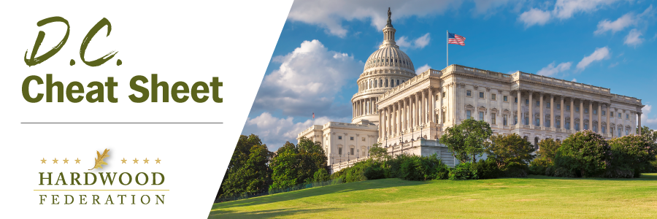

Quick Updates from Your HF Team

House Tax Chief to Focus on Small Business Relief
Ways and Means Committee Chairman Jason Smith (R-MO), the top tax writer in the House, has raised some alarms in the broader business community by singling out small business, while omitting mention of bigger job creators, as the top item on his agenda for the 118th Congress. The chairman’s omission of support for big business marks a departure from the traditional rhetoric of GOP leaders, who have typically treated large corporations and small business as co-beneficiaries of federal tax relief. Although Congress isn’t reviewing legislation at the moment that would raise the corporate rates above 21%, for example, Democrats consistently push for an increase in corporate taxes whenever budget legislation moves through Congress, especially when looking for offsets for proposed spending increases. Chairman Smith’s failure to mention bigger companies in his “to do” list raises questions about the robustness of opposition his committee would mount in the event lawmakers place corporate tax rates in the crosshairs.
Senate Ag Committee Spotlights Forest Management in Upcoming Farm Bill
On March 1, Senate Ag Committee Chair Debbie Stabenow (D-MI) and Ranking Member John Boozman (R-AK) presided over a hearing to gain input from USDA and review a broad spectrum of conservation and forestry programs that will be included in the upcoming Farm Bill. That said, lawmakers wasted no time in diving into a detailed discussion on how to reduce wildfires through effective forest management. Industry ally and Ranking Member Boozman asked one of the three committee witnesses, USFS Associate Chief Angela Coleman, about specific ways that the agency could promote wood products to achieve their wildfire prevention goals. Coleman responded that the USFS supports creation of a “healthy timber-producing infrastructure” and more wood innovation grants as pillars for effective land management and wildfire mitigation. Stay tuned for regular updates on the Farm Bill as it moves through Congress this year.

Fly-In 2023!! REGISTER TODAY!
The Hardwood Federation Fly-In is back in 2023!! Make plans today to join us in Washington, D.C. from Tuesday, June 13 to Thursday, June 15. Meet your federally elected officials. Tell your story. Network with your peers. To see for yourself what HF has lined up, check out the full schedule of events. Registration is now open, so make plans to join us ASAP. The Federation has arranged for a limited number of rooms at a special rate at our host hotel, the Washington Hotel Monaco. Be sure to reserve yours today. To sign up for the Fly-In and reserve your room, please click HERE!.

