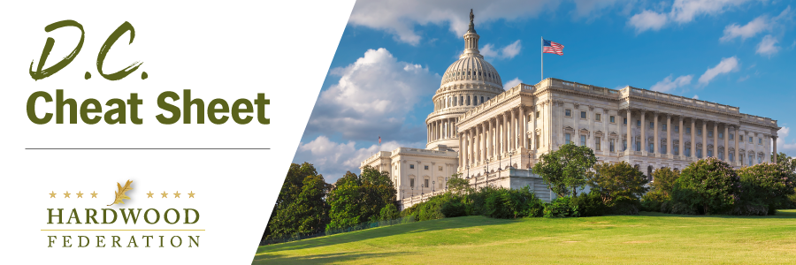

Quick Updates from Your HF Team

Contact Your Senators Today! Fight for Hardwood in the Farm Bill
Send a letter today and fight for one of the Hardwood Federation’s primary goals for the 2023 Farm Bill, which is to establish a competitive grant program to support consumer education about the sustainability, low carbon footprint, domestic production and rural economic impacts of U.S. made hardwood products. Please review and send the letter included here and help us by reaching out to your senators. Feel free to personalize your letter as appropriate! Time is of the essence as Committee members have been asked to submit their recommendations no later than Friday, March 31

Sen. Thune (R-SD) Introduces Forest Management Bill
On March 15, Sen. John Thune (R-SD) introduced the Expediting Forest Restoration and Recovery Act, legislation that will require the U.S. Forest Service (USFS) to fast-track treatment of more than 70 million acres of National Forest System lands that have been identified as requiring treatment to reduce the threat of insect and disease infestations and wildfires. “Proactive management plays a critical role in keeping the [forests] healthy and supporting the forest products industry, which supports jobs in rural communities,” said Thune. In addition to prioritizing treatment of forestland threatened by disease and wildfires, the bill would also require the USFS to publish an annual report detailing the acres that have been treated. The Federation will keep you posted on the bill’s progress as it moves through the legislative process.
Hardwood Industry, Allies Push for Lower Taxes on Family Businesses
Anticipating a tax debate in Congress as lawmakers turn to budget matters, the hardwood industry and its allies in the small business community are taking some pre-emptive steps to maximize flexibility under the complex tax code. The Federation recently signed a joint letter led by the Family Business Estate Tax Coalition to support Sen. Thunes’ (R-SD) “Death Tax Repeal Act,” a bill expected to be introduced next week that would rescind the estate tax altogether. A companion bill is also expected to gain traction in the House, pending Ways and Means Committee Chairman Jason Smith’s (R-MO) appointment of a member on his panel to lead the charge on the House version.

Mark Your Calendar! The Federation Fly-In is Back, June 13 – 15, 2023
To sign up and reserve your room, please click HERE!.

