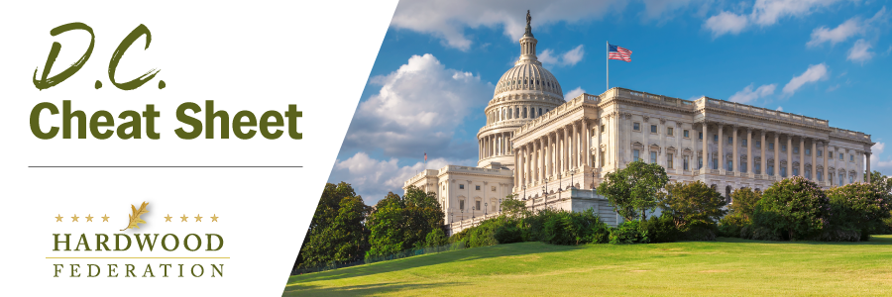

Quick Updates from Your HF Team

Federation Advocates for Hardwood Education Program

The Federation is making the rounds on the Hill to advocate for a Hardwood Products Access and Development Program within the 2023 farm bill, focusing on House and Senate Ag panel members and other leaders on industry issues. Recent House side meetings include HFPAC events with Reps. Chavez-Deremer (R-OR), David Rouzer (R-NC), Mike Simpson (R-ID) and Carol Miller (R-WV). The Federation has also connected with key Senate Ag Committee members, including the offices of Sens. Ernst (R-IA), Fetterman (D-PA), McConnell (R-KY), Smith (D-MN) and Stabenow (D-MI), who chairs the committee.

Hardwood Industry Contacts Senators, Lobbies on Farm Bill

Building on the farm bill theme, during the past week, more than 150 members of the hardwood industry have sent letters to their senators urging inclusion of a Hardwood Products Access and Development Program within the 2023 farm bill. As the Senate Agriculture Committee wraps up requests from senate colleagues at this stage of the legislative process, members of the hardwood sector can still make an impact to push the industry’s agenda forward. Contact your U.S. senators by sending a letter today!

Industry Urges Administration to Expedite West Coast Port Talks

The Hardwood Federation has joined more than 100 industry groups in a letter to the Administration urging completion of a final agreement between labor unions and Pacific maritime ports. The labor contract expired in July 2022, adding uncertainty to ongoing supply chain disruptions and bottlenecks at the west coast ports. Industry urges the Administration to continue to engage both parties in productive talks to avoid a strike, while pointing out that many stakeholders have already shifted cargo to other ports, avoiding the West Coast altogether.

Mark Your Calendar! The Federation Fly-In is Back, June 13 – 15, 2023
To sign up and reserve your room, please click HERE!.

