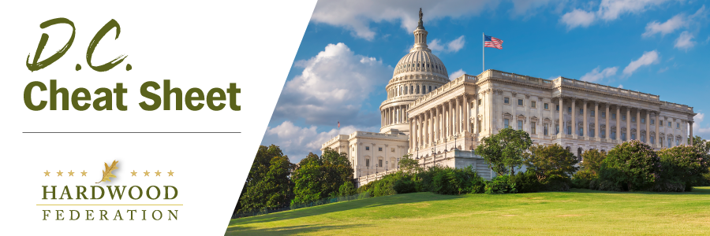

Quick Updates from Your HF Team

Debt Ceiling Showdown Creates Pivot to Dollars and Cents Tax Debate
As Congress turns its attention to broader fiscal matters such as the debt ceiling and federal budget for Fiscal Year (FY) 2024, lawmakers have begun to roll out tax legislation that they hope will incentivize economic growth in an uncertain economic climate. Highlights include the bipartisan and bicameral American Investment in Manufacturing (AIM) Act, introduced by Sens. Shelley Moore Capito (R-WV) and Kyrsten Sinema (I-AZ) and Reps. Adrian Smith (R-NE) and Joe Morelle (D-NY), to restore important business interest deductions and the Accelerate Long-Term Investment Growth Now (ALIGN) Act, introduced by Sen. Jim Lankford (R-OK) and Rep. Jodey Arrington (R-TX) on March 30 to make 100% expensing of heavy duty equipment permanent. Even under an expedited legislative schedule, tax bills take several months to move across the finish line and are more often than not bundled into a single package at the end of the calendar year. Given this timetable, the Federation has placed tax policy as a high priority for the June Fly-In, creating an opportunity to build momentum for legislation that will maximize fiscal flexibility for hardwood companies.
Wood Products Group Weighs in On Low-Carbon Construction Materials

On May 1, the Hardwood Federation joined the Decorative Hardwoods Association and Composite Panels Association in comments to EPA, responding to the agency’s Request for Information related to low-carbon construction materials. The wood products allies urged federal regulators to consider sustainable forest management while recognizing the low carbon footprint of finished wood products, especially when compared to other materials such as glass and concrete. The coalition also cited two Environmental Product Declarations (EPDs) from the Decorative Hardwoods Association and National Hardwood Flooring Association outlining the “total cradle-to-grave global warming potential” for engineered wood flooring and solid wood floors.

Coalition Supports Ocean Shipping Implementation

The Federation joined more than 70 trade associations in a letter to congressional leaders calling attention to the problem of rail storage, a form of demurrage, which is charged by railroads as part of international ocean transportation at the nation’s interior rail terminals. In recent years, these demurrage charges have resulted in costs to U.S. businesses in the hundreds of millions of dollars. Unfortunately, when containers are delayed at the railyard because of the railroad's terminal operations, rail storage charges accrue and undercut the transportation streamlines offered by Ocean Shipping Reform Act passed in 2022, which pushes back on similar demurrage fees imposed at the nation’s ports. The Federation will keep you posted on advocacy related to ongoing transportation bottlenecks that hinder delivery of hardwood products to their customers.

Mark Your Calendar! The Federation Fly-In is Back, June 13 – 15, 2023
To sign up and reserve your room, please click HERE!.

