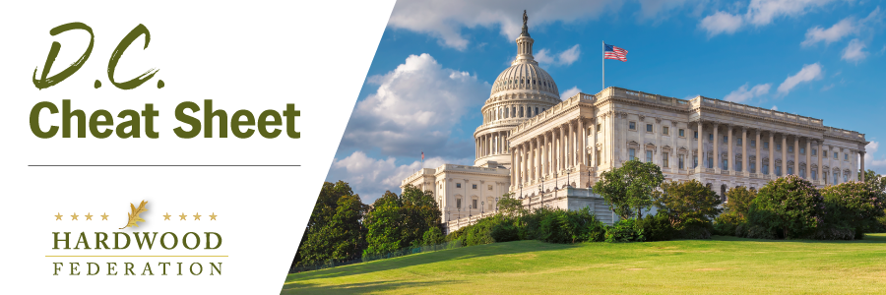
Quick Updates from Your HF Team
Hardwoods Take E.U. Deforestation Rules to the U.S. Trade Representative
On November 28, the Hardwood Federation and AHEC met with officials at the USTR to discuss the industry’s concerns about the EU’s now final deforestation rules that among other things, will require geo-location of fiber included in the manufacture of wood products. This follows an informational session for forestry allies on October 30 where the AHEC team shared their challenging experiences working with the E.U. and proposed solutions for meeting the standard. The USTR agrees with the hardwood industry (and other impacted industries) that the rule is ill conceived and almost impossible to adhere to. They also shared their ongoing efforts to push back on the rule and asked that we keep them appraised on efforts to engage E.U. industry partners. The Federation will keep you posted on developments as they unfold.
Congressional “To Do” List Stacks Up Before Holidays
With Congress kicking off a two-week sprint for its break currently scheduled to begin on Friday, December 15, lawmakers have several key votes to cast before leaving Washington. In addition to continuing negotiations to address the FY 2024 budget before expiration of the current Continuing Resolution (CR), Congress also needs to reauthorize the National Defense Authorization Act, the traditional vehicle for mass timber programs. There is also mounting pressure from the business community to address taxes. Other bills heading for a potential logjam include passage of the remaining nine Senate and seven House FY 2024 appropriations bills and potential supplemental funding for Ukraine aid and border security.
Hardwoods, U.S. Chamber Review NEPA Legislation
On November 29, the U.S. Chamber conducted a coalition meeting featuring Rep. Rudy Yakym (R-IN), who co-introduced the “Studying NEPA’s Impact on Projects Act” H.R. 6129 with Rep. Jim Panetta (D-CA). The bill promotes transparency in the federal permitting process by requiring the White House Council on Environmental Quality to compile a report on NEPA-related litigation, including a breakdown of their outcomes, to expose frivolous lawsuits that can add several years to the NEPA review process. It would also require reporting of aggregate page counts for permits and account for the length of time used to produce Environmental Impact Statements (EIS), which form the basis of NEPA permits. Rep. Yakym hopes to advance the bill by driving co-sponsors and possibly attaching it to a FY 2024 appropriations bill.

