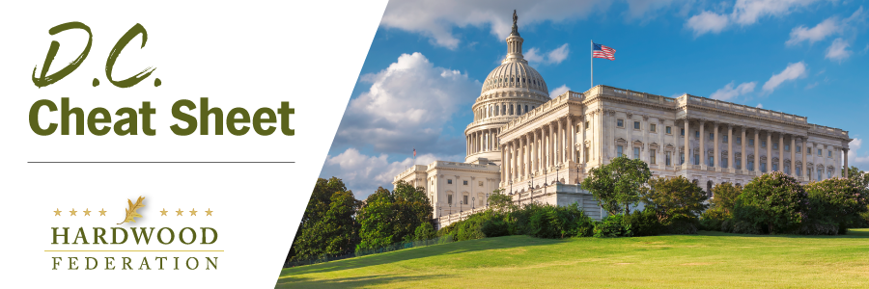

Quick Updates from Your HF Team
Senate Ag Committee Leaders Support Exports
Despite delays in finalizing a new farm bill, Senate Ag Committee Chair Stabenow (D-MI) and Ranking Member Boozman (R-AK) sent a letter to USDA Secretary Vilsack urging the Administration to use additional tools in its toolbox, specifically resources from the Commodity Credit Corporation, to “build new markets … for American grown products,” including hardwoods. The bipartisan senators state that they are responding from organizations urging USDA to “strengthen trade opportunities, increase revenue streams, and help producers grow … in a global economy. The senators’ bipartisan letter bodes well for more resources for the Foreign Market Development and Market Access programs, a top priority for the hardwood industry.
Biden Administration Issues New WOTUS Rule, Again
On August 29, the EPA issued a new rule to clarify the scope of federal Clean Water Act jurisdiction through its definition of “Waters of the United States” (WOTUS) and comply with the Supreme Court’s decision in Sackett v. EPA. The high court’s action effectively overturned key elements of the more expansive rule issued in January 2023, remanding the issue to federal agencies for a redo. The new rule, however, although dropping the “significant nexus” test used by federal regulators to expand the scope of water permits, bypassed the public comment process on the grounds that the exercise was confined to legal revisions mandated by the Supreme Court. Barring substantive amendment of the CWA by Congress, an unlikely event in the current climate, the agencies’ decision to fast-track the latest WOTUS opens the door for more litigation.
Hardwoods, Industry Allies Oppose Corporate Transparency Act Mandates

The Federation is joining dozens of other industry groups urging lawmakers to delay implementation of the Corporate Transparency Act of 2021, which will impose major reporting requirements on small and medium sized businesses beginning in 2024. In an effort to combat financial crimes, the CTA will, as a general matter, require most existing and new corporate entities in the U.S. to file disclosures with the Department of the Treasury regarding their beneficial owners. The Federation and its allies oppose the law’s implementation on the grounds of federal overreach and overly burdensome paperwork requirements.

