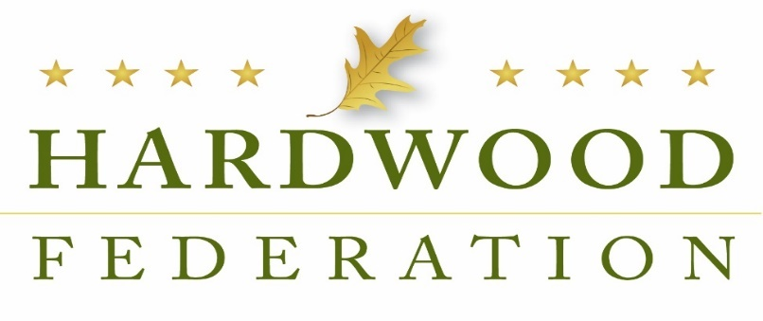
Hardwood Federation – June 2023 Newsletter

From the Executive Director: Federation Fly-In Comes Back in June, Takes Up Next Generation of Advocates
The Federation Fly-In came back on June 14 and June 15, following a three-year hiatus in the wake of COVID measures that restricted access to Capitol Hill. Nearly 70 hardwood industry leaders conducted over 100 bipartisan, congressional meetings, advocating for hardwood priorities in the farm bill, tax legislation and transportation legislation. Included in the mix this year were several members of the hardwood industry’s next generation, an experience in the policy world that would be difficult to replicate in the classroom. We hope the Fly-In served as an opportunity to inspire these young people to not only actively engage in the democratic process but see firsthand how federal legislation can impact the daily operations of hardwood businesses.
Leading the priority list - for veteran and youth advocates alike - was the farm bill, which last passed in 2018 and is up for reauthorization in 2023. Specifically, advocates recommended recognition of the carbon capture value of hardwood products in federal accounting programs, inclusion of a hardwood products grant program to educate consumers about the sustainability of hardwood products, and doubling funding for USDA export promotion authority.
While pro-hardwood USDA programs dominated conversations in all congressional offices, industry leaders were able to deliver key messages to nearly half the U.S. Senate, racking up 40 meetings. Highlights included discussions with nine of the 21 members of the Senate Agriculture Committee, which is busy drafting its version of the farm legislation. Conversations in the offices of Agriculture Committee Chair Debbie Stabenow (D-MI) and Ranking Member John Boozman (R-AR) figured prominently in the meeting series. Geographical diversity also characterized the breadth of this year’s Fly-In. In total, participants visited Senate and House offices from 21 states in every region of the country.
On the House side, conversations focused on especially timely topics. Because House committees recently passed tax and transportation packages that will likely move on the floor later this year, industry messages were especially timely. On the tax policy front, advocates recommended permanence for 100% bonus depreciation and the Section 199A small business deduction. Transportation policy was also a high priority, with participants advocating for a House Transportation Committee package that includes truck weight flexibility, streamlining the process for obtaining a Commercial Driver’s License (CDL) and expediting implementation of ocean shipping reforms enacted in 2022. Focusing on members of Congress who represent districts where industry members live and work, the hardwood team conducted more than 60 meetings with House lawmakers.
After Hill meetings wrapped on Wednesday afternoon, participants headed to the Capitol Hill Club to thank House-side Republican friends of the industry with a social hour. Following the reception, House Ag Committee Chair GT Thompson (R-PA) addressed the group during dinner and outlined a path forward for the farm bill, noting the importance of working together in a bipartisan fashion. On Thursday, June 15, the Fly-In concluded with a breakfast reception, also on Capitol Hill where attendees mingled with Democrat lawmakers who have a demonstrated track record of supporting the industry.
[Insert family photo]
[Insert family photo]
Issues:

Congress Returns to the States for the Fourth of July

As Congress breaks for the Fourth of July Recess until the week of July 10, be on the lookout for your federal lawmakers as they make the rounds of parades and barbecues. In the event you see your elected officials, be sure to remind them of the Federation’s key “asks” driven home during the June Fly-In. Repetition is key to transforming the following messages into law:

- Farm Bill – Congress should create a grant program that educates the public about the sustainability benefits of hardwood products. Also, USDA programs must recognize the carbon capture value of hardwood products and get credit in all Farm Bill-related carbon accounting programs.
- Taxes – Congress must make permanent 100% expensing of industrial equipment and the 20% deduction for small business. Congress should also restore full deductibility of business expenses.
- Transportation – Congress must pass a “supply chain package” that creates flexibility for truck weights, grows the dwindling pool of trucker drivers and expedites implementation of ocean shipping reforms.

Like the Halloween Movie Franchise, WOTUS Keeps Coming Back

In the wake of the Supreme Court’s decision in May to limit the scope of the Clean Water Act per the requirements of the beleaguered “Waters of the United States Rule,” federal regulators are moving forward with a new and improved WOTUS rule to comply with the court’s ruling. According to a statement from the Administration delivered during a House Transportation hearing, the EPA and Army Corps of Engineers will issue a final rule, likely this summer, with no intervening comment period, therefore expediting compliance with the high court’s ruling. The new and improved regulation is expected to include provisions clarifying that a “continuous surface connection” between a larger water body and wetland must be in place in order to trigger federal permitting requirements over commercial and agricultural activity.
HF Reviews USDA’s Latest Proposal on Forest Management
In late April, the USFS released an Advance Notice of Proposed Rulemaking (ANPRM) requesting feedback from stakeholders on next steps to implement an Executive Order to strengthen the nation’s forests, issued in April 2022. Shortly thereafter, the Federation submitted comments on a “Request for Information,” also from the USFS on mature and old growth forests, during which time industry advocated against a “one size fits all” regulatory definition. The deadline for the latest round of comments currently falls on July 20, per an industry request to extend the original deadline of June 20. That said, industry arguments will center on the necessity of forest management as an indispensable tool to promote and maintain “climate resilient” forests, the over-arching goal of the Administration’s current exercise.

USFWS Proposes to Tighten Endangered Species Rules

When Congress goes on recess, federal agencies often kick the regulatory process into high gear. On June 21, the United States Fish and Wildlife Service (USFWS) proposed three modifications to ESA standards in an attempt to address what the agency describes as weakened protections implemented by the Trump Administration. In a nutshell, the trio of proposals seek to:

- Specify that the agency may not consider economic impacts when making reclassification, listing and delisting decisions, reversing a practice favored by the previous Administration.
- Reinstate the long-standing “blanket” 4(d) rule while retaining the option for regulators to adopt a species-specific 4(d) rule;
- And revise the interagency consultation process.

The Federation is currently reviewing the proposals for comment.
.
House Tax Package Moves to Front Burner

When the House Ways and Means Committee passed a tax package on June 13, it launched legislation that serves as a vehicle for some of the hardwood industry’s top priorities. Included in the mix are provisions that extend full expensing of equipment until 2027 and restoration of business interest deductibility, known in accounting-world as Earnings Before Interest, Depreciation and Amortization (EBITDA) until 2026. House leaders hope to move the package to the House floor before the August recess.

While the small business provisions rise to the top of industry priorities, House Ways and Means Committee Chairman Jason Smith (R-MO), a longtime champion of small and family-owned businesses, has identified a temporary raise of the standard deduction by $2000 for individual filers and $4000 for married couples as the central feature of the package. The legislation, known as the Working Families Tax Cut Act, offered by Reps. Nicole Malliotakis (R-NY) and Michelle Steel (R-CA) would apply the more robust deductions for the 2024 and 2025 filing years.
Labor Talks at West Coast Ports Move Toward Consensus
On June 14, the International Longshore and Warehouse Union and the Pacific Maritime Association announced a tentative agreement on a new six-year deal, injecting some certainty into a turbulent labor/management dynamic that has characterized west coast ports during the past year. Despite efforts by industry and the Administration to resolve labor talks at the nation’s western ports, including a tentative agreement reached in April 2022, disruptions occurred in May, including closure of the largest terminal at the Port of Long Beach. Stay tuned for other developments that may unfold as parties to the negotiations attempt to implement the latest agreement.

